**Data Movement’s Follow the Sun (FTS) - Handoff Tool & Process**

**Guide for Support Engineers**

This Guide assumes the following:

* You are a support engineer active on VDM.
* You’re familiar with the current [Big Data / Data Movement handoff process](https://dev.azure.com/Supportability/Big%20Data/_wiki/wikis/Big-Data.wiki/306262/Case-Handoff-Process)

How to Access the FTS Tool

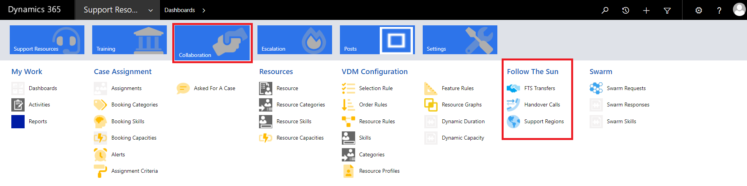

1. In Edge Browser:  [https://crmglobal.corp.microsoft.com/GLBCRMSUP/](https://crmglobal.corp.microsoft.com/GLBCRMSUP)
2. Go to **Collaboration**, then **FTS Transfers** under “**Follow The Sun**” title

Cases Automatically Added to FTS

Cases that meet the criteria below will be automatically added to the FTS list to be approved for transfer.

* Sev A “CritSit” cases not marked as “Waiting for Confirmation”
* Sev B and 27x7 flagged cases not marked as “Waiting for Confirmation”

How to Add a Case to Transfer

Steps to add your case to the transfer list.

1. Open CRM in Edge Browser:
2. Search your case number in the search bar on the top right.  
   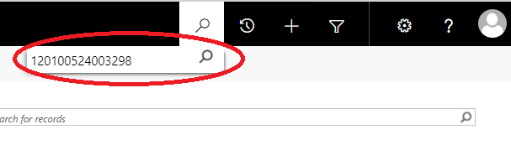
3. Select your case under “Service Requests”  
   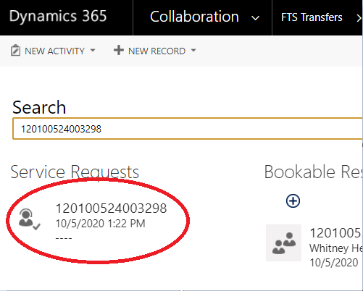
4. In the top bar, click the drop-down next to the case number.  
   
5. Select “FTS Transfers”  
   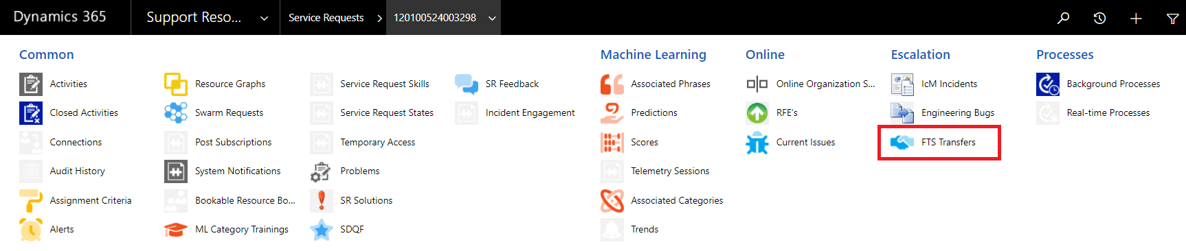
6. Select “+ Add New FTS Transfer”  
   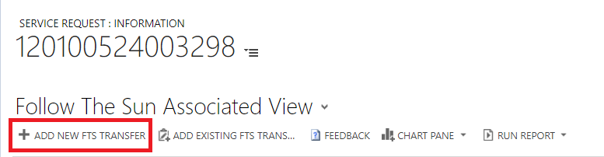
7. Fill out the FTS form with the appropriate information through to “Ensure Summary”  
   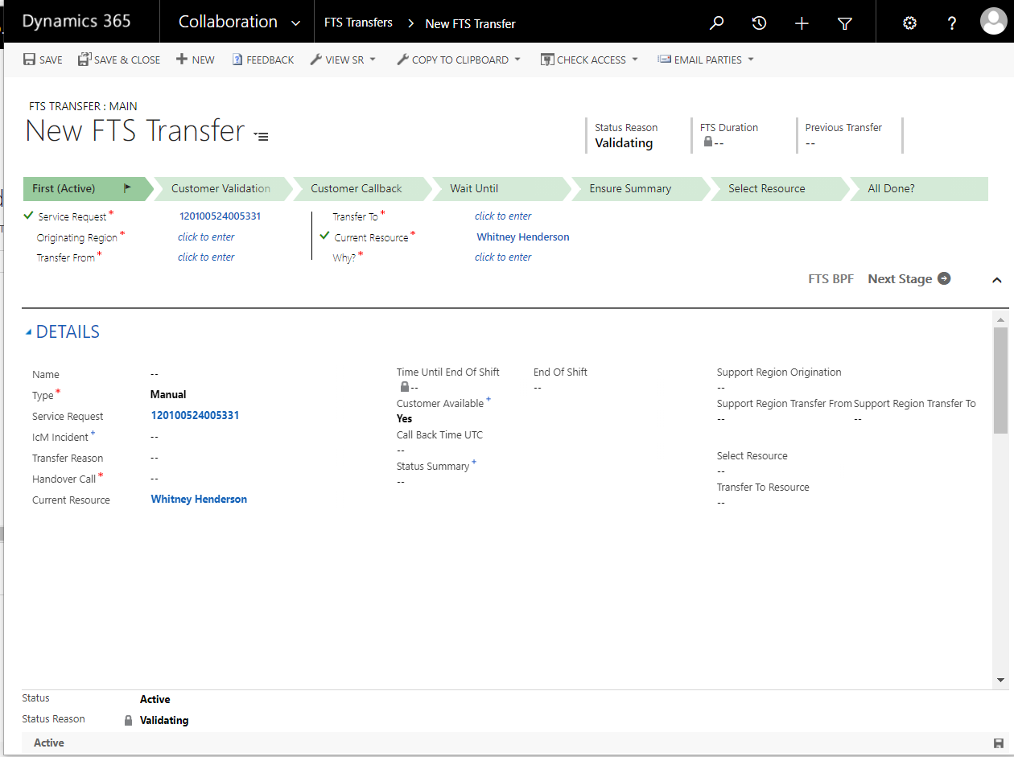  
     
   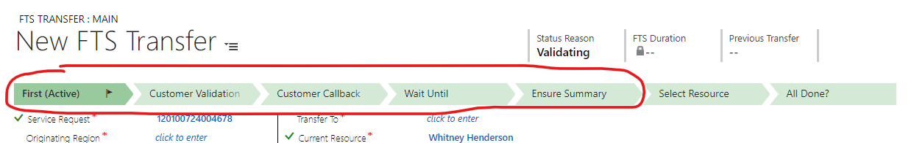
8. At the handover call time, your case assignment lead will review the handover, select a resource, and process the transfer.  
   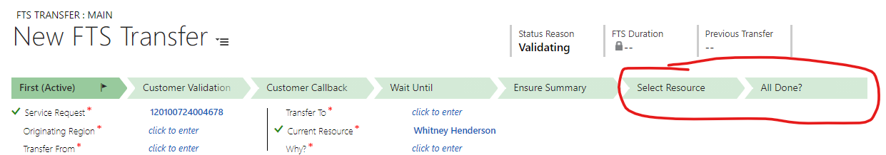

How to Skip a Region in FTS

Let us say, for example, you have a case in AMER that needs to skip APAC and go straight to EMEA.  
You can use FTS to perform this transfer.  
  
1. You fill out your FTS transfer as normal, and in the “Transfer To” section, you pick THE NEXT REGION. Choose the next handover call and the next region, as the case will still need to pass through that region to get to the region you need. So for our example, you would still choose “APAC” as the next region, and the APAC handover call as the next handover call.  
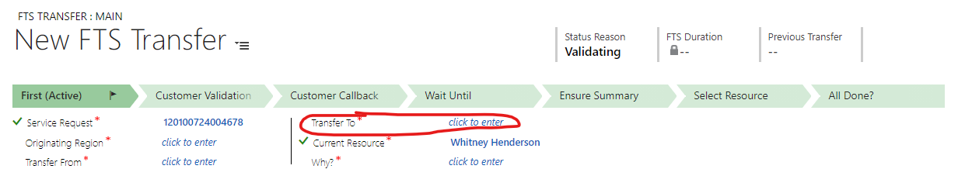  
  
2. Fill out the rest of the transfer as normal, and in the summary notes specify that the case needs to skip a region and why.  
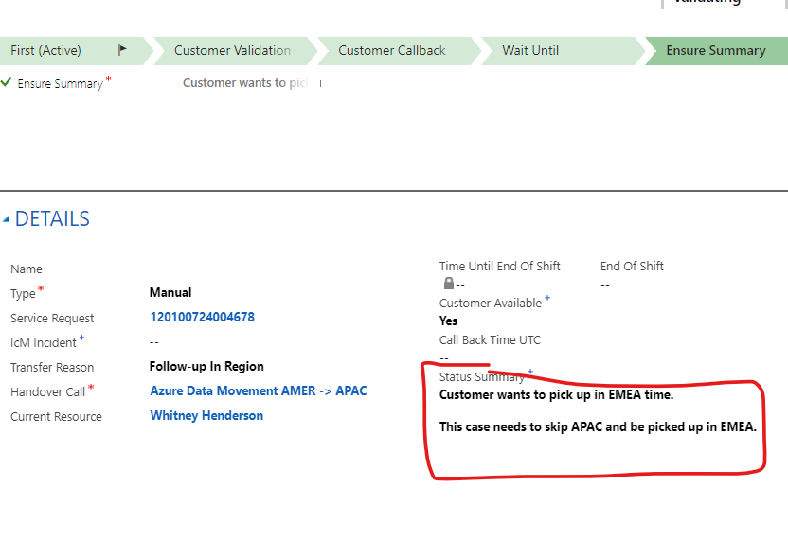  
  
3. Then in the “Select Resource” Section the Lead will see that the case needs to skip the region and choose “Skip”. The transfer will then skip the region and be moved to the next, where the leads can choose to process the assignment for that region.

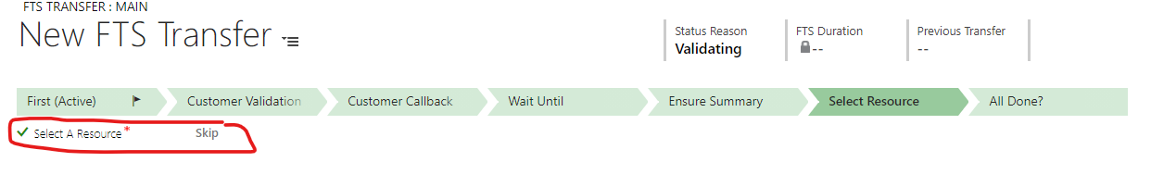

How a Case is Transferred After It Has Been Added

A case that has been added, automatically or manually, to the list will be approved for transfer by a lead, as shown in steps 7 and 8 of the guide above.

After it has been approved for transfer VDM will find a skilled engineer in the destination region and will automatically assign that engineer, like for any other case.

If a case has been previously transferred, FTS will favor transferring to an engineer who has owned the case in the past.

Handover Calls

Handover calls still exist and are an integral part of FTS.

During the handover calls our leads will review all cases slated for transfer and select a resource (either selecting “Automatic” to allow VDM to assign to an available resource or “Manual” to choose a specific resource to take a case.)

If a case slated for handover needs to be discussed, the handover call will be the teams chat/location to facilitate the discussion, much as our calls today.  
  
When we initialize FTS, the handoff calls should be joined to make sure cases are appropriately transferred.  
  
As we become familiar with the process, the handover calls can be used to facilitate discussion of more interesting cases.